Rialivhuwa Mabudafhasi
Practical 1: Basic SQL Syntax

Question1
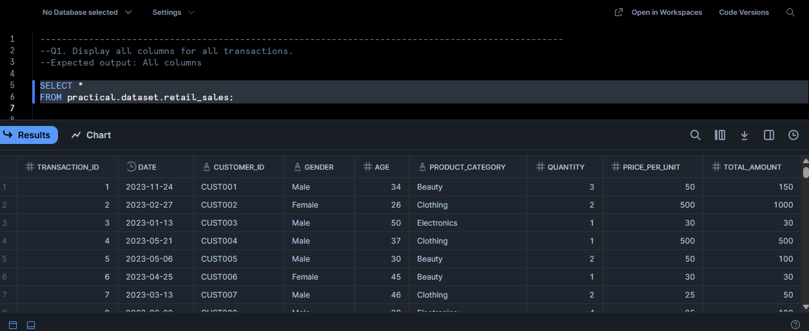

Question 2
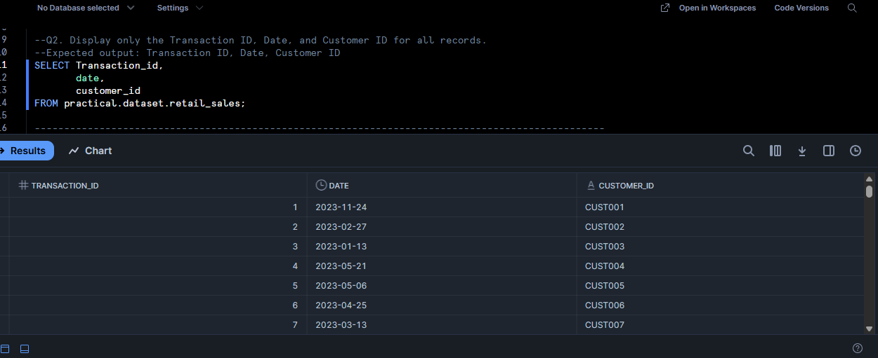

Question 3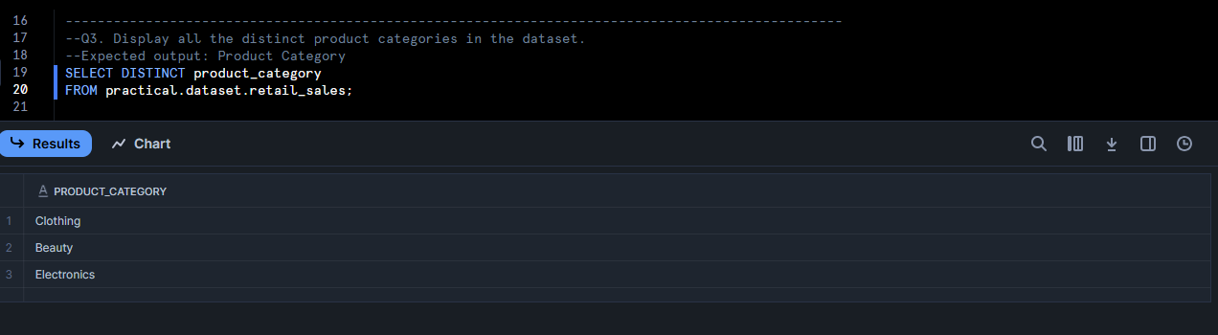
Question 4

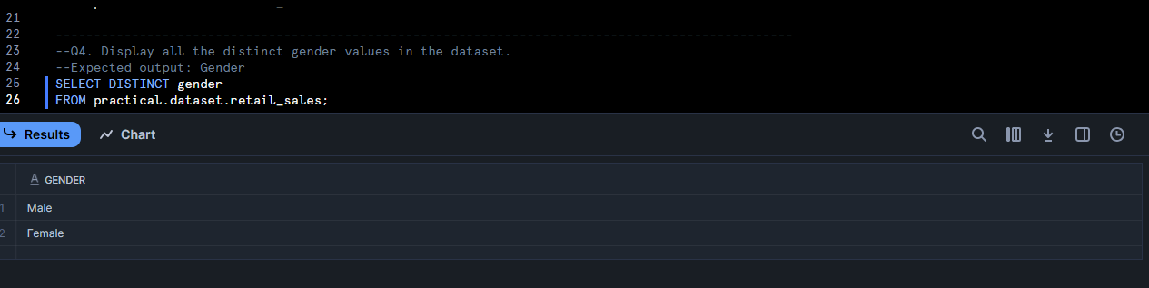
Question 5

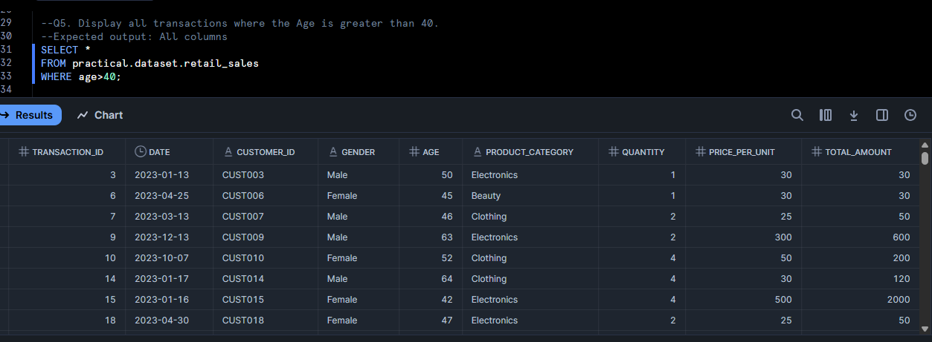

Question 6
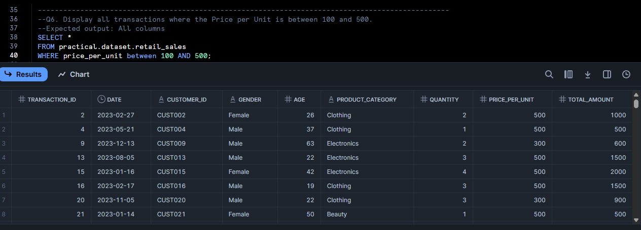

Question 7
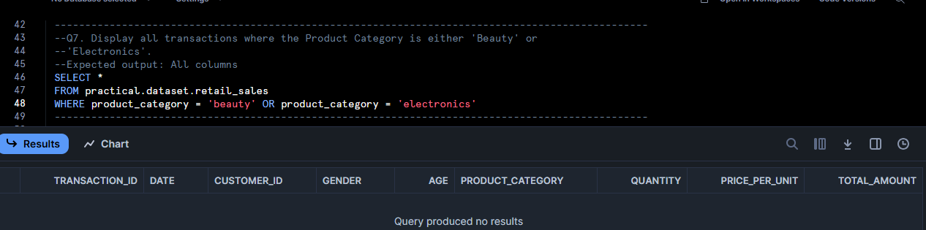

Question 8
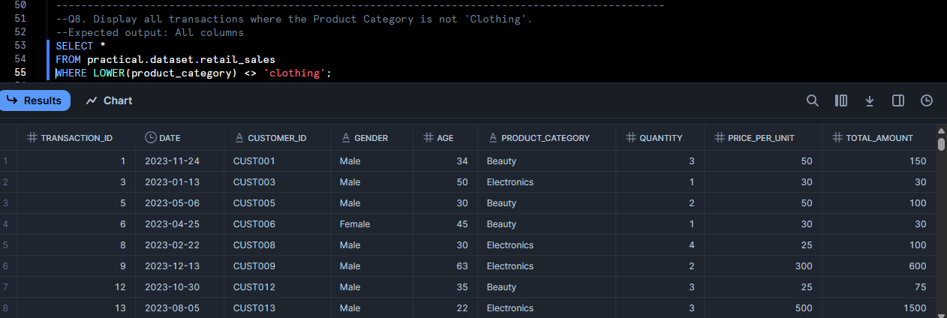

Question 9
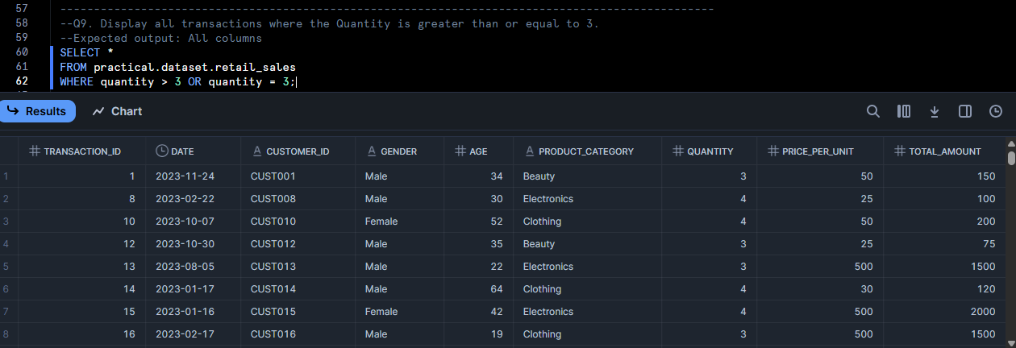

Question 10
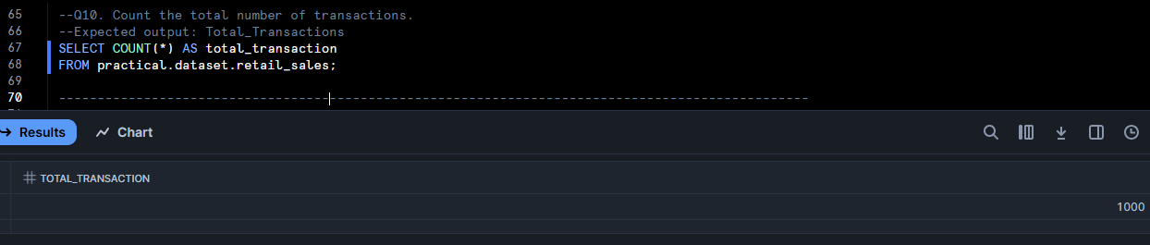

Question 11
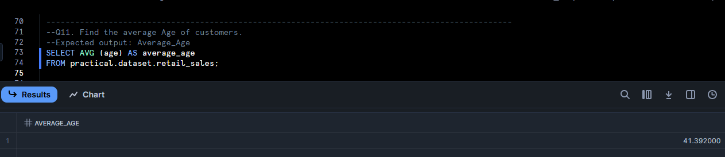

Question 12
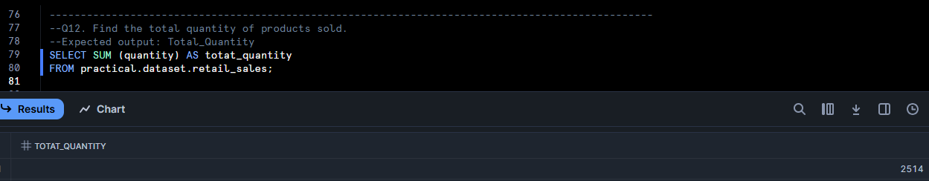
Question 13
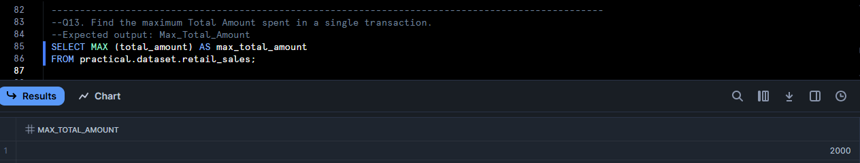

Question 14
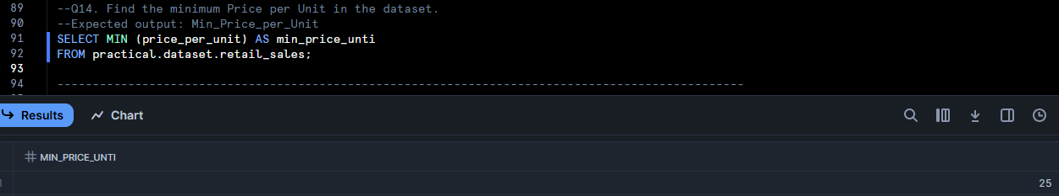

Question 15
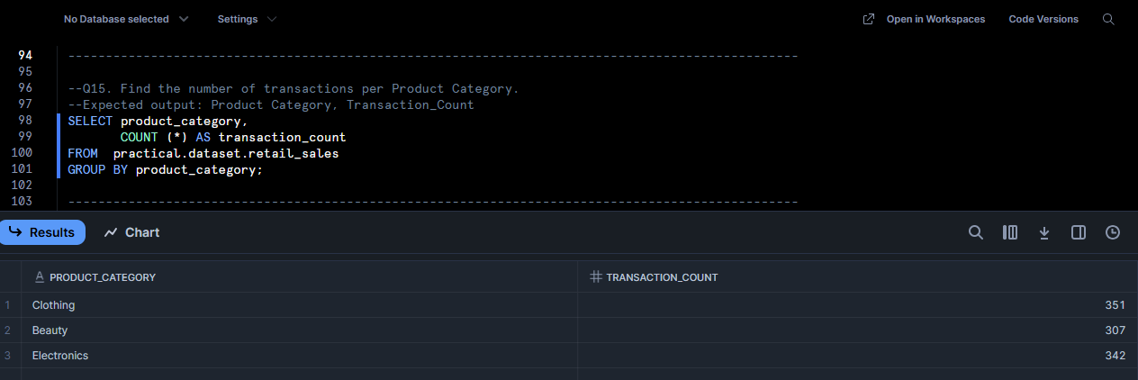

Question 16
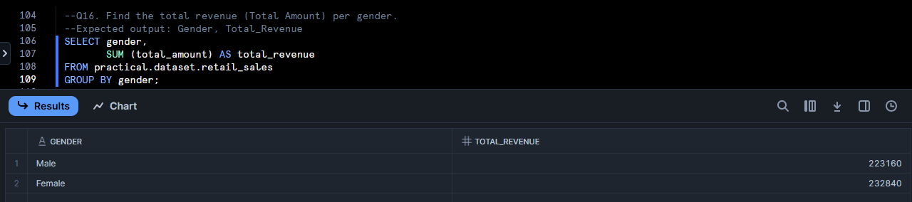

Question 17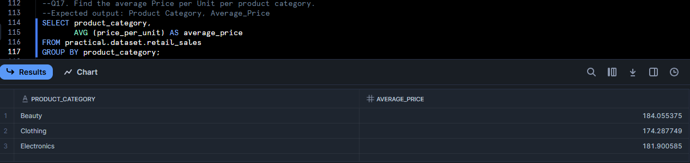

Question 18
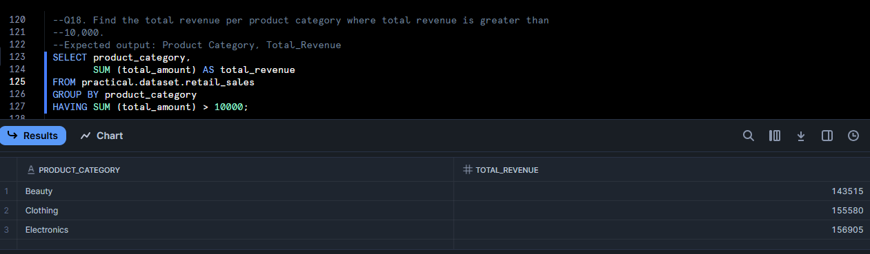

Question 19
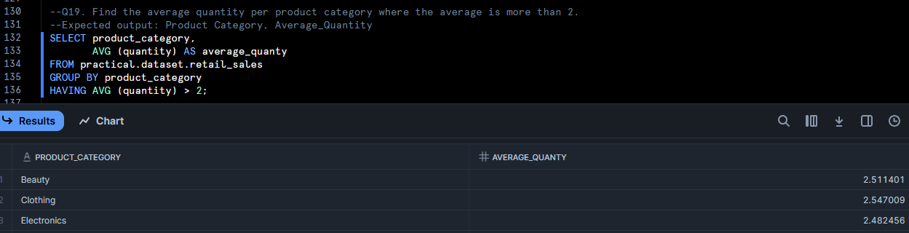

Question 20
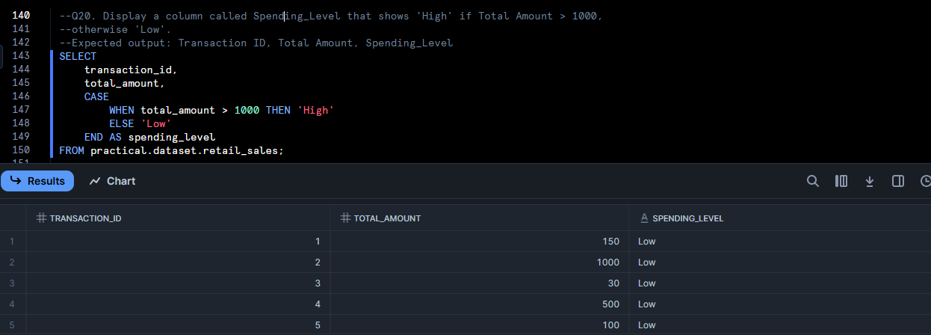

Question 21
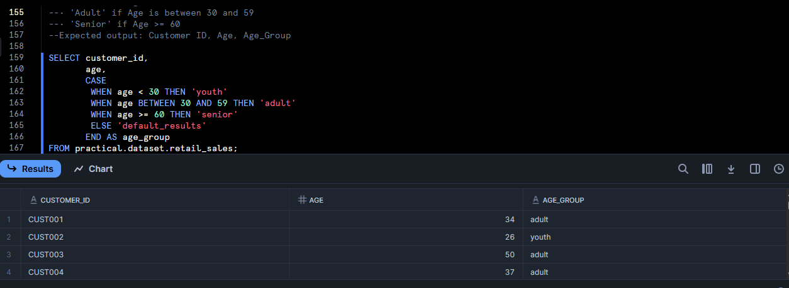
The struggle I faced with Q21 is position of CASE and the WHEN, it couldn’t read until I got the format right. But I won.

